Preisliste Kunststoffterrarien:

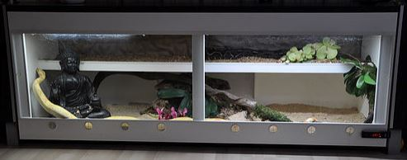

Breite x Tiefe x Höhe Preise inkl. 19% Msst. Technik-Paket Ablage
( Heatpanel + Led Beleuchtung )

100 / 60 / 60 295,00 120,00 35,00
100 / 70 / 40 320,00 120,00 35,00

120 / 60 / 60 360,00 120,00 40,00
120 / 70 / 50 380,00 120,00 40,00
120 / 70 / 60 395,00 120,00 40,00

140 / 60 / 60 400,00 140,00 50,00
140 / 70 / 60 440,00 140,00 50,00
140 / 70 / 70 460,00 140,00 50,00

150 / 60 / 60 495,00 148,00 55,00
150 / 70 / 60 520,00 148,00 55,00
150 / 70 / 70 550,00 148,00 55,00

Für die Montage des Technik-Paket wird ein Betrag von 25,00 € berechnet.

